FrSky Taranis and APM:SITL
How to make them communicate.
(Or any other Joystick, for that matter...)

Prerequisites:
- SITL installed and working on a virtual Ubuntu machine in MS Windows 7.
Instructions to do that can be found here: http://www.rcgroups.com/forums/showpost.php?p=28711757&postcount=2
- MissionPlanner 1.3.5 or later installed and configured to connect to SITL. MissionPlanner can be found here: http://ardupilot.com/downloads/?did=82
- An FrSky Taranis, capable of working as a joystick in Windows7. (I use OpenTX 2.0.5 and later.(Joystick was broken in OpenTX 2.0.4))
(Any other joystick should be able to work, but you'll need to experiment on your own.)

If you are using a Taranis, I recommend that you setup a dedicated SITL-model before continuing.
Ideally, copy your APM-equipped model, and switch off all RF-modules in the new model.

Heres how it looks in the OpenTX Companion 2.0.x setup tab:
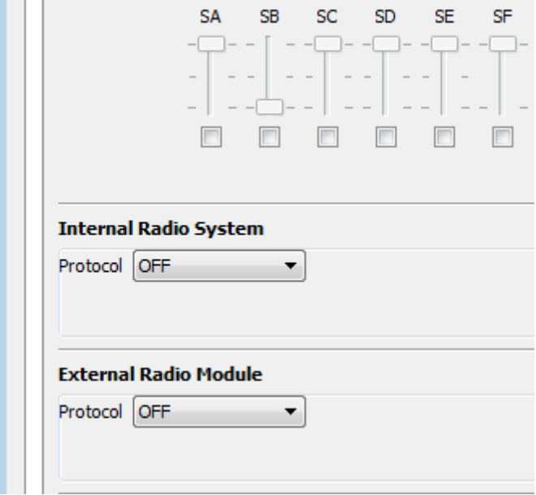

The really easy (cheating) way:
You can use MissionPlanner to connect a joystick to SITL. Joystick data is then sent over MavLink via the UDP interface. It's very easy to setup and works with virtually any joystick.

Connect a joystick to any USB-port. Verify that it works in Windows.
Start Sitl and connect to MissionPlanner.
Find and press the button "Joystick" in MissionPlanner – Flight Data – Action Tab.
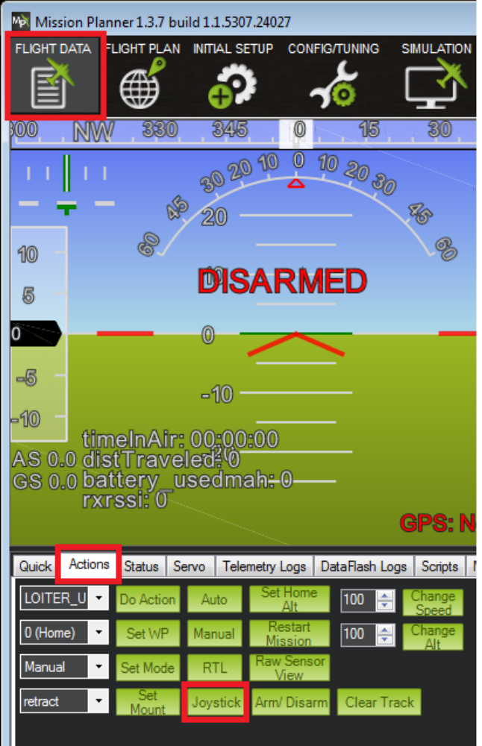

A new windows opens:

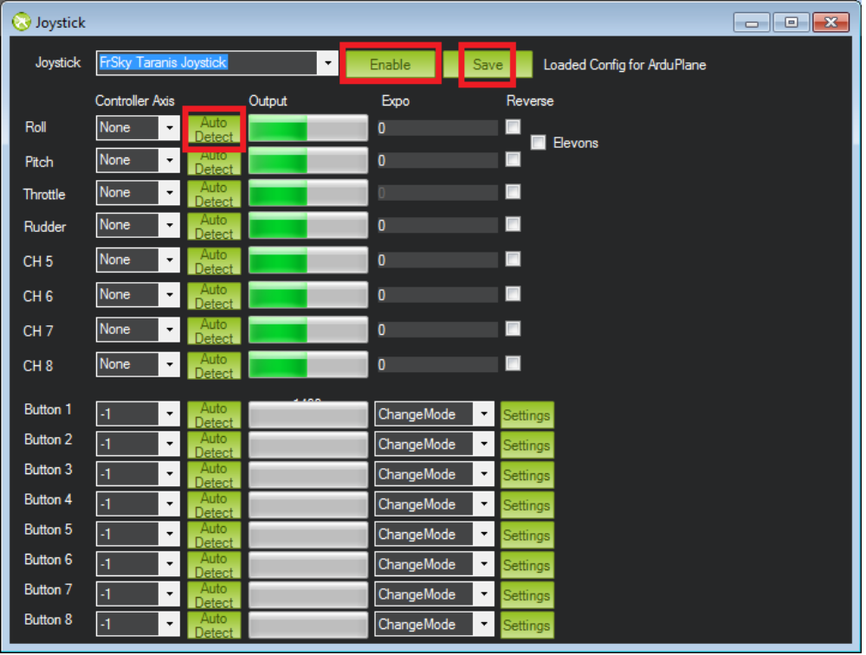

You should see your joystick in the upper left corner.
Press enable, then use the “Auto Detect”-button for each channel. Follow the instruction that pops up.
Press “Save” when ready.
If you haven't already, now is the time to start SITL and connect MissionPlanner.
Calibrate Radio in MissionPlanner – Initial Setup - Mandatory Hardware - Radio Calibration.'

That's it. You now have a joystick that can be used to maneuver your Copter/Plane/Rover

Too easy?? Read on for a more challenging way to do it....;)

The not-so-easy way:
Connect your joystick direct to SITL, to emulate a real world setup.

Step 1:
Install required software in Ubuntu

In Ubuntu, open a terminal.
Type: sudo apt-get install jstest-gtk python-pygame [enter]
Enter your password when prompted, and answer “Y” to any questions that pop-up
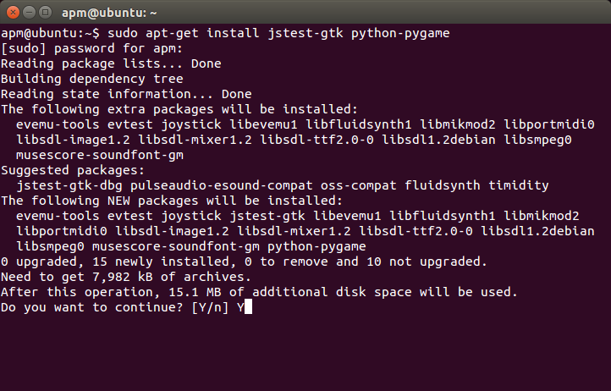
Let the download and installation finish.
Step 2:
Connect your Taranis joystick and configure it.
Press the stupid “dishwasher”-icon in the top left.
Type: jstest
Drag the jstest-icon to the icon-row on the left
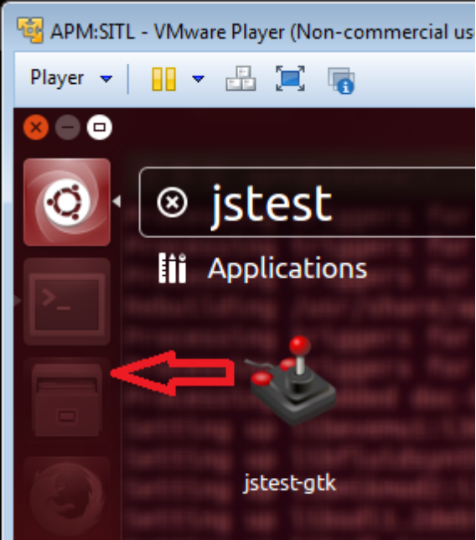

Switch on your Taranis and connect it to any USB-port.
Verify that it's working in Windows7 Devices and printers.

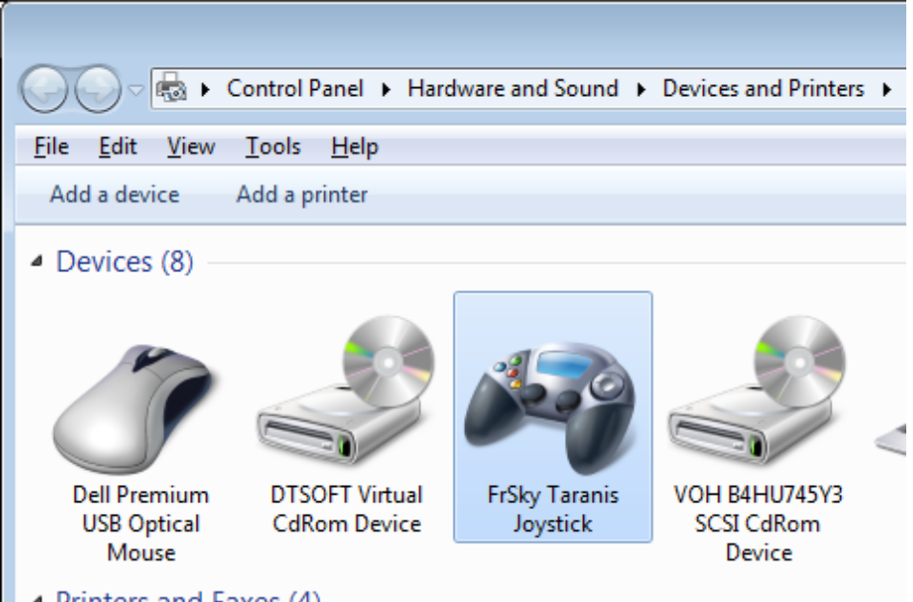
Next you need to “divert” the Taranis Joystick to Ubuntu.
Select the “Player”-menu in Vmware.
Select: Removable Devices – SGS FRSky Taranis Joystick – Connect.

Now, select the icon for Jstest. You should see your Joystick.

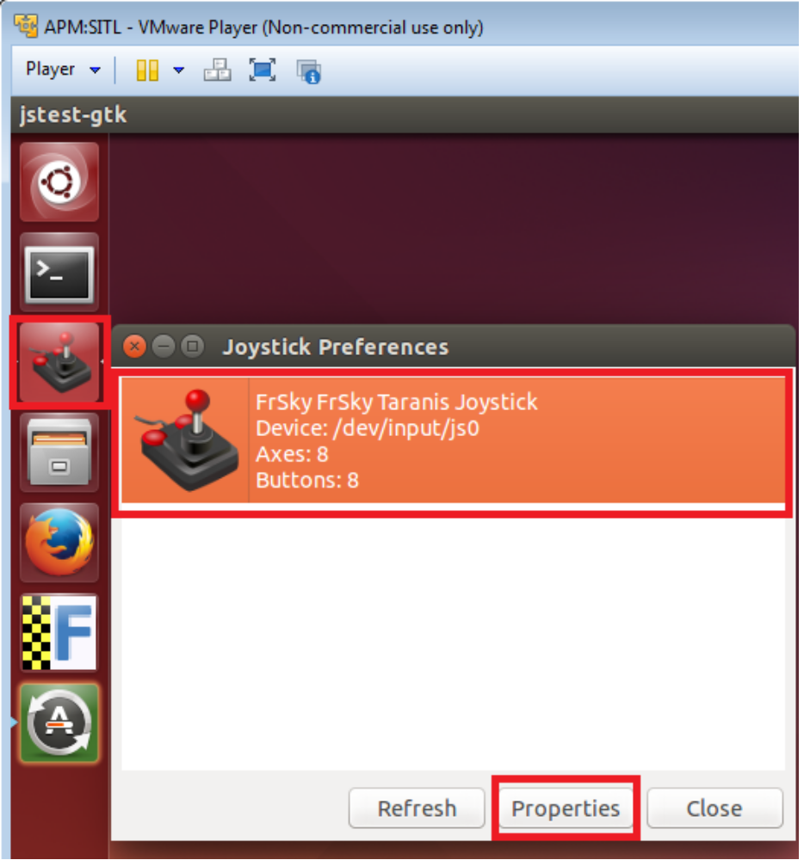

Select “Properties”, and verify that things happen when you move the sticks on the Taranis.
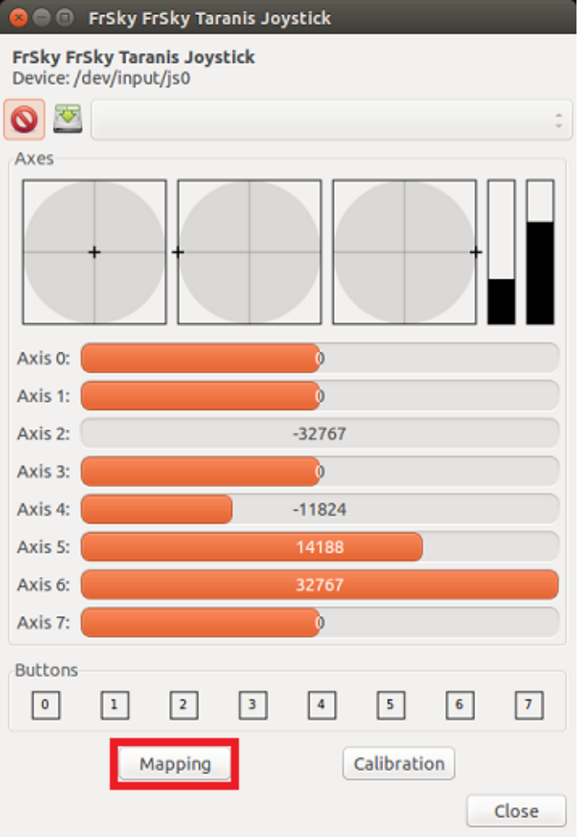
The mapping button will come in handy later.
You can play with it if you like, but how you end up, depends on your model settings in the Taranis.

Here's what my mapping looks like:
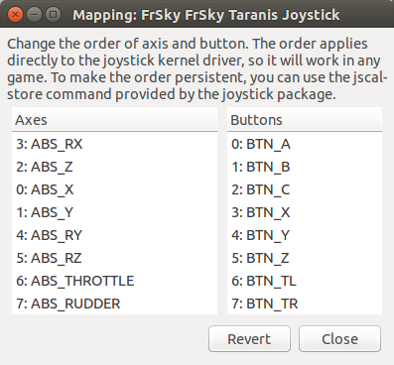

Next we need to add an entry for the Taranis in the file:
/usr/local/lib/python2.7/dist-packages/MAVProxy/modules/mavproxy_joystick.py

To be able to do that, you need to change permissions for that file.
I've made it easy for myself and changed permissions for the whole /usr/local/lib folder.

Open a terminal and type:
sudo chmod 777 -R /usr/local/lib [enter]

Enter your password when prompted
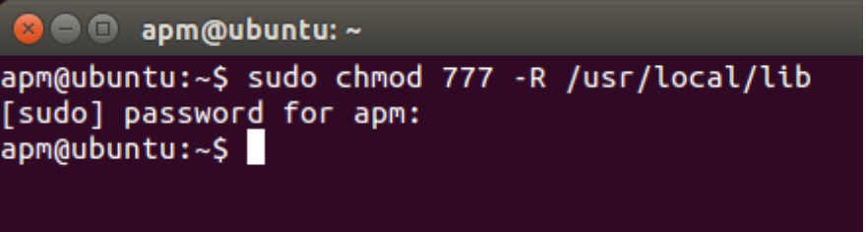

Open the file: (Use gedit)
/usr/local/lib/python2.7/dist-packages/MAVProxy/modules/mavproxy_joystick.py

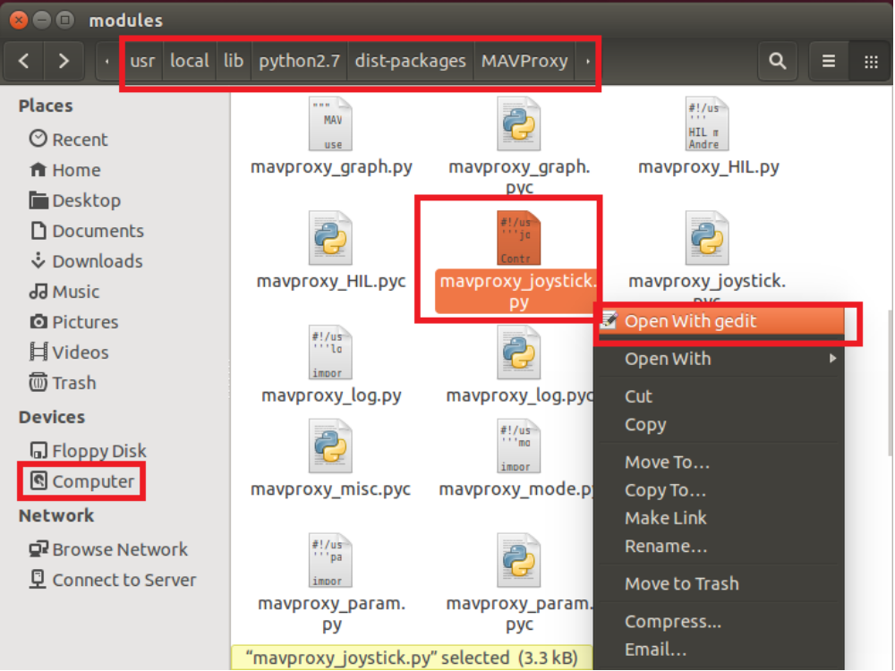
Add the following to the file:

'FrSky FrSky Taranis Joystick':
# has 8 usable axes.
[(0, 500, 1500),
(1, 500, 1500),
(2, 500, 1500),
(3, 500, 1500),
(4, 500, 1500),
(5, 500, 1500),
(6, 500, 1500),
(7, 500, 1500)]

Also, add a comma after the entry for the 'Great Planes GP Controller'.
See the highlights below.
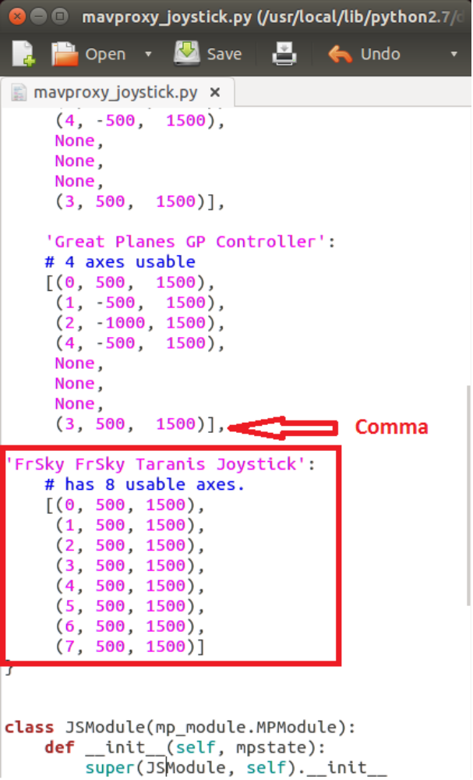

Save and exit.

Step 4:
Load the Joystick Module in SITL, and configure radio in MissionPlanner

Start SITL with your favorite vehicle.
I'm using plane in this example, but the steps are identical for Copter and Rover.

In the MavProxy terminal, type: module load joystick [enter]
If all went well, you'll see the following:
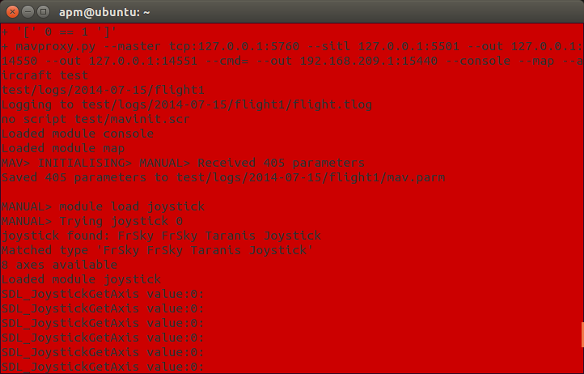
You'll also see the message SDL_JoystickGetAxis value scroll all over your terminal, with values changing as you move the sticks.

Connect to MissionPlanner, and verify your channel selections and directions in MissionPlanner – Initial Setup - Mandatory Hardware - Radio Calibration.

Fly and have fun with your new joystick.:)

Many thanks to all the ArduPilot developers who made this possible.

